**Adding Custom Footprints**

Similar to the custom schematic symbol issue, you will need to add custom footprints. I just included all of the ones I have created so far. Most of the ones I added aren’t even used for this project but everything that is should be included. In the “Printed Circuit Board Editor”, go to preferences -> footprint libraries wizard.

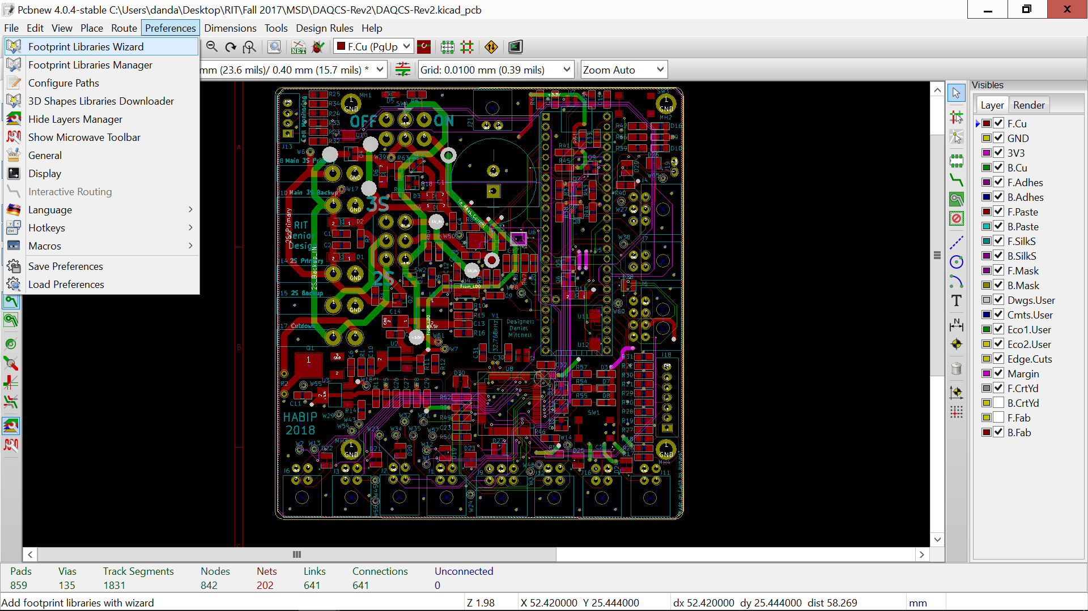

Select “Files on my Computer”

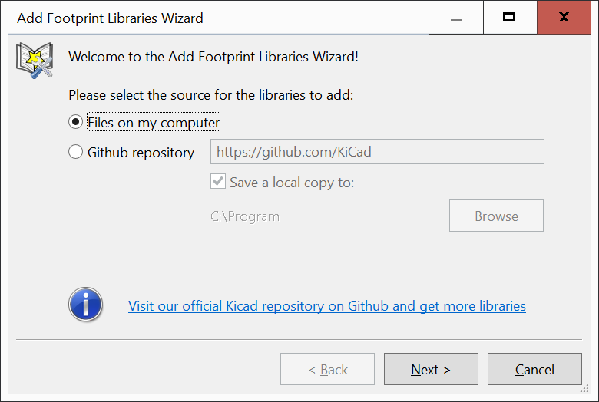

Navigate to the correct folder which contains the custom footprints and select it.

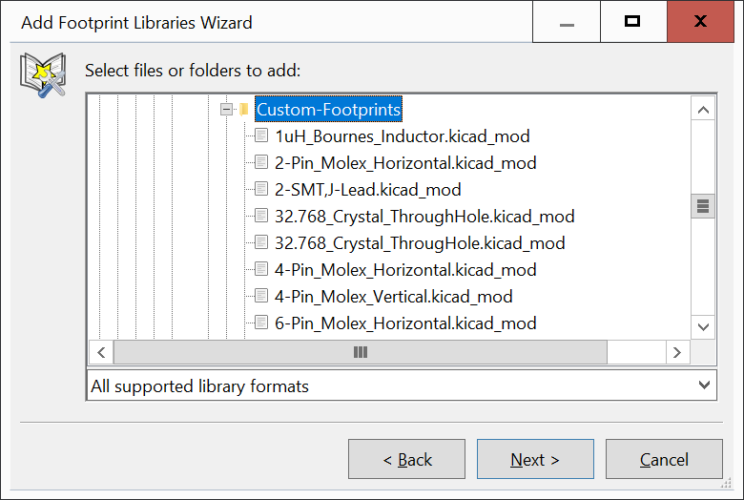

Select “Next” and then “Okay”. You can choose to add these footprints to the current project only or globally to all projects. Then click finish

